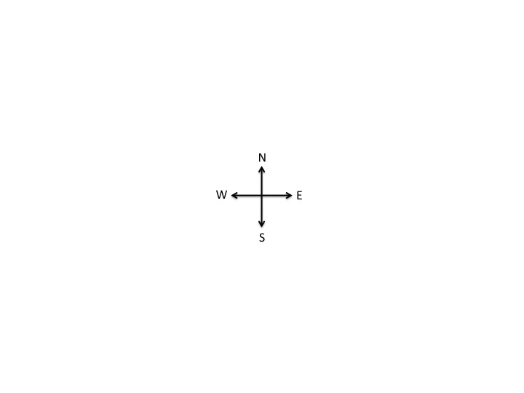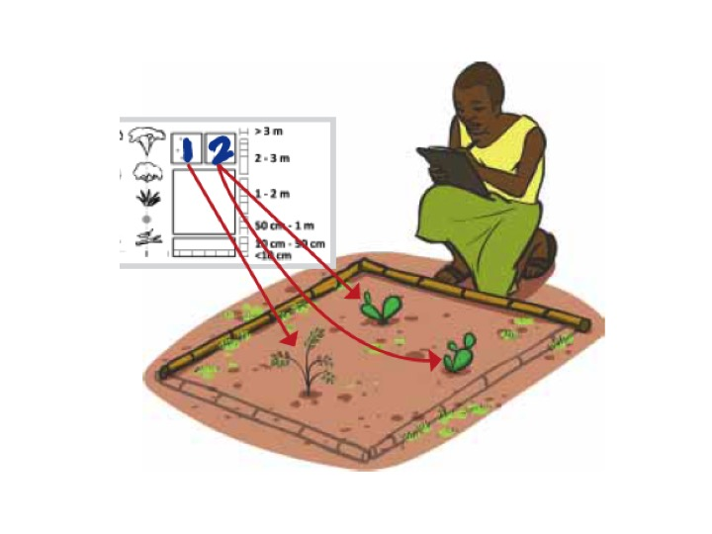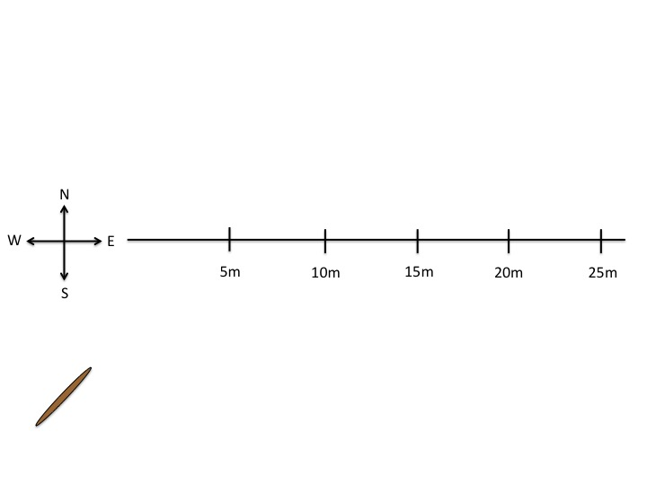

FADE TO: A quick visual of a person walking the entire 25m and collecting density data will be shown.

FADE IN: A second stick appears perpendicular to the first stick, outlining the 1x1m plot. Two of the same plant types will be circled in red.

OPEN TO: The cross appears at the center of the screen. One of its arms extends outward. A person begins to walk with a stick, and places it on the ground in front of his feet.